Assignment 2: Part 1: ML as a service

# Identifying and working with sensitive healthcare data with Amazon Comprehend Medical

## Services used for the Architecture:

1. Amazon Comprehend Medical to identify entities within a body of text
2. AWS Step functions and AWS Lambda to coordinate and execute the workflow
3. Amazon DynamoDB to store the de-identifying mapping

## For the architecture we built following Lambda functions:

1. IdentifyPHI

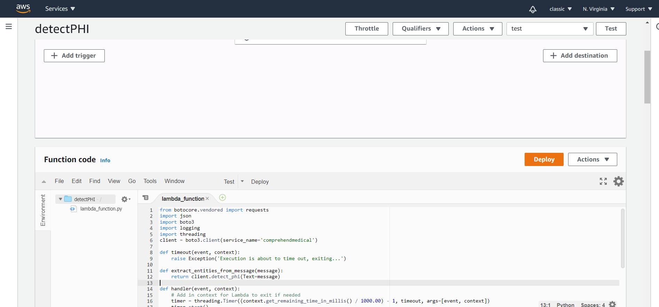

1. MaskEntities

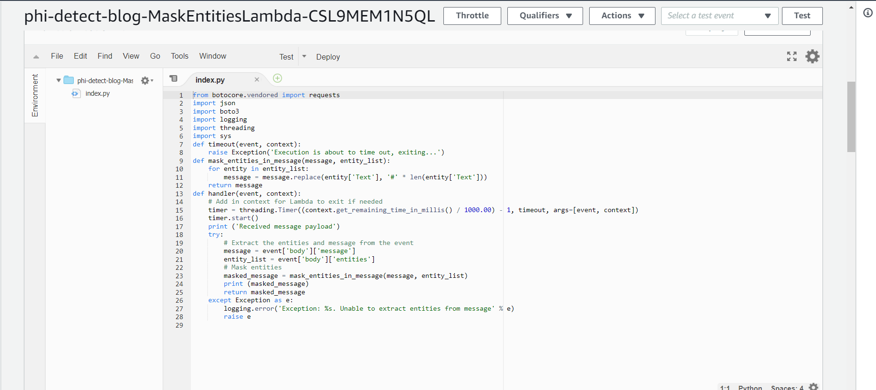

1. DeidentifyEntities

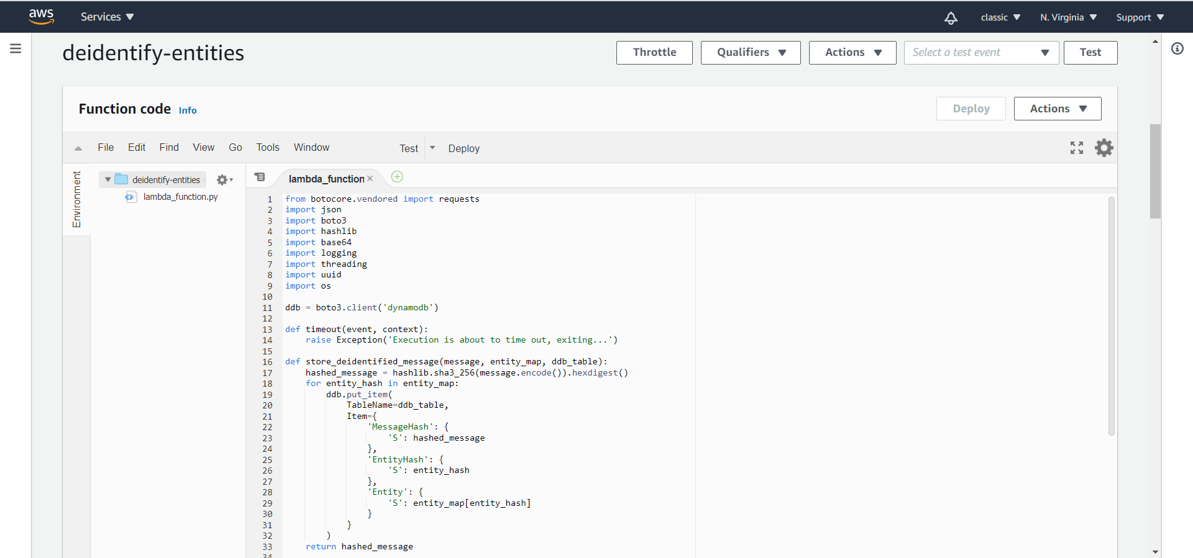

# The Workflow execution :

1. The Lambda function identifies potential PHI entities within the note.
2. These entities then get salted and the resulting combination gets hashed using SHA3-256.
3. Replaces the original entities with the hashes in the message and then hashes the updated message.
4. Stores the mapping in DynamoDB.
5. Returns the hashed message as the output of the execution.

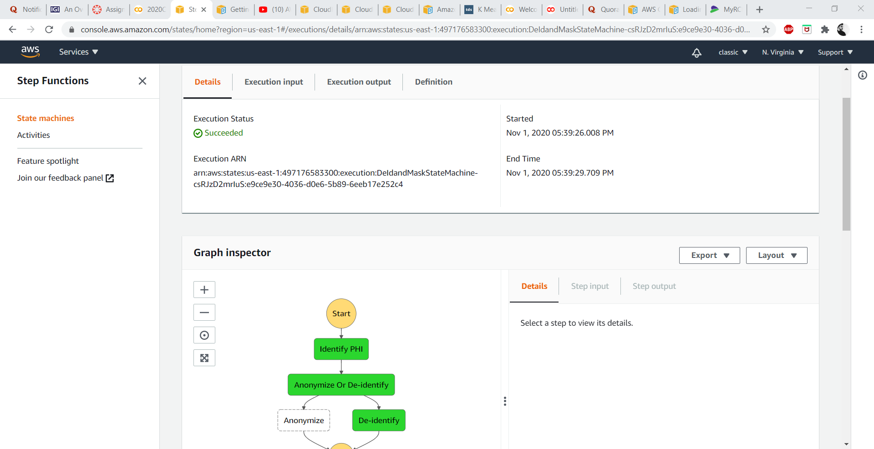

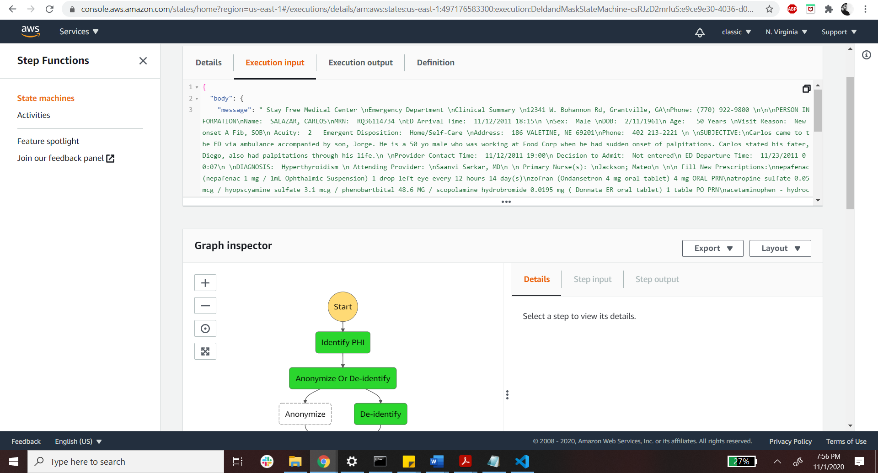

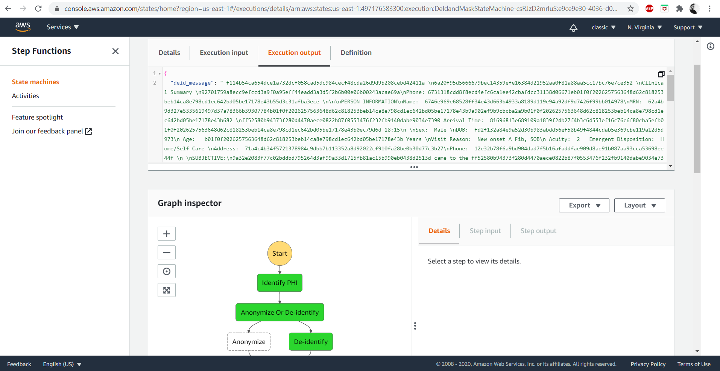

# Conclusion:

1. Identified the sensitive entities.
2. Applied the appropriate protection strategy for those sensitive entities.